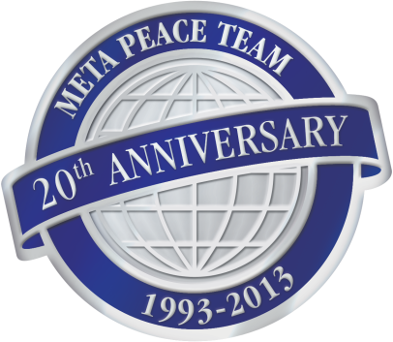
IMPORTANT
Semester & Year in which you are interested: __________________

Meta Peace Team: INTERNSHIP APPLICATION

Name: ______________________________________________

Address: _________________________________________________________________

Phone: ________________________________________________

Email: ___________________________________________________________

Skills (may include past work history): _______________________________________________________

Interests related to MPT: __________________________________________________________________

Time commitment: _______________________________________________________________________

FOR OFFICE USE:
Projects assigned:

_________________________________

_________________________________

_________________________________

_________________________________

_____________________________

_____________________________

_____________________________

_____________________________
Comments/Misc:

________________________________________________________________

________________________________________________________________

Meta Peace Team
Internship Expectations and Objectives

Name: Click here to enter text.

Please identify your objectives for interning at Meta Peace Team (what do you hope to learn?):

1)

2)

3)

How would you describe your learning style? For example, are you a visual learner or an oral learner? In other words, do you prefer to have written explanations or discussion?

Do you feel comfortable working independently? Do you prefer to work in groups?

Please rank the following internship activities from 1-3 per the drop-down menus
(1 = really enjoy, 2 = okay, 3 = dislike)

Choose an item. Watching documentary films
Choose an item. Reading books
Choose an item. Reading articles
Choose an item. Researching (predominately with the internet)
Choose an item. Working in groups
Choose an item. “Grunt” work (copying, filing, etc.)
Choose an item. Making phone calls

(Describe):

